🔍 Multimodal AI System for Crop Disease & Insect Prediction

i) CVAT (Offline) Setup Procedure
- Install Docker:
  - Download Docker Desktop from https://www.docker.com/products/docker-desktop
  - Install and ensure Docker is running.
- Download CVAT Repository:
git clone https://github.com/opencv/cvat.git
cd cvat
- Start CVAT (Offline Mode):
docker-compose build
docker-compose up -d
Access CVAT:
- Go to http://localhost:8080
- Default login:
  - Username: admin
  - Password: admin

ii) Annotation Techniques Used
- Tool Used: CVAT (Offline)
- Annotations Format: YOLO format
- Image Types:
  - Disease Images → Annotated with bounding boxes using class names like blight, rust, etc.
  - Insect Images → Annotated with bounding boxes like aphid, caterpillar, etc.
- Process:
  - Created annotation tasks per dataset (disease, insect)
  - Uploaded all 50 images to each
  - Drew bounding boxes for each object
  - Exported annotations as YOLO format.

iii) Annotated Dataset
- Folder Structure:
datasets/
├── disease/
│ ├── images/
│ ├── labels/
│ ├── annotations.xml
│ └── cvat_xml_to_yolo.py
└── insect/
├── images/
├── labels/
├── annotations.xml
└── cvat_xml_to_yolo.py

Download Link (Google Drive):
https://drive.google.com/drive/folders/1glNmsjWRfnC4ZKVsBf-xlJzqJPvl1cJ4?usp=drive_link

iv) Architecture of the Multimodal System

🔹 Short Description:
- A Multimodal AI system that:
  - Uses YOLOv8 object detection on crop images to detect diseases and insects.
  - Uses a TabNet model to predict the crop condition from structured CSV data.
  - Combines both predictions in a fusion layer (rule-based) for final decision-making.

🔹 Pictorial Representation:
Insect Image
CSV Crop Data
Disease Image

TabNet Model
(tabnet_model.pth)
Final Result (Disease/Insect + CSV Decision
Fusion Script Output Decision
YOLOv8 Model
(insect.pt)
YOLOv8 Model
(disease.pt)

v) Implementation Codes (Organized Structure):
multimodal/
├── cvat/ # CVAT annotation setup, XMLs, etc. (optional)
├── datasets/ # Contains:
├── disease/
├── images/
├── labels/
├── annotations.xml
└── cvat_xml_to_yolo.py
└── insect/
├── images/
├── labels/
├── annotations.xml
└── cvat_xml_to_yolo.py
├── fusion/
└── fuse_all_outputs.py # Combines outputs from YOLO + TabNet
├── tabnet_disease/
├── crop_disease_characteristics.csv
├── predict_tabnet.py # Predict using trained model
├── tabnet_disease_model.zip # Trained model weights
└── train_tabnet.py # Model training code

├── tabnet_insect/
├── crop_insect_characteristics.csv # Input features for insect tabular model
├── predict_tabnet.py # Predict using trained model
├── tabnet_insect_model.zip
└── train_tabnet.py # Model training code

├── yolov8_disease/
├── yolov8_disease_results/ # Inference results/screenshots
├── config.yaml # YOLOv8 config
├── detect.py # YOLO inference script
├── train.py # YOLO training script
├── yolov8s.pt # Detection model

├── yolov8_insect/
├── yolov8_insect_results/ # Inference results/screenshots
├── config.yaml # YOLOv8 config
├── detect.py # YOLO inference script
├── train.py # YOLO training script
├── yolov8s-seg.pt
└── yolov8s.pt # Detection model

├── README.md # Complete documentation (intro, steps, credits)

fusion
fuse_all_outputs.py
from ultralytics import YOLO
from pytorch_tabnet.tab_model import TabNetClassifier
import numpy as np
import os

# ---- YOLO Disease Detection ----
yolo_disease_model = YOLO("../yolov8_disease/yolov8_disease_results/crop_disease_segmentation4/weights/best.pt")
yolo_disease_result = yolo_disease_model.predict(source="../datasets/disease/images/train/disease9.jpg", conf=0.25, save=False, verbose=False)
has_disease = len(yolo_disease_result[0].boxes) > 0

# ---- YOLO Insect Detection ----
yolo_insect_model = YOLO("../yolov8_insect/yolov8_insect_results/crop_insect_detection/weights/best.pt")
yolo_insect_result = yolo_insect_model.predict(source="../datasets/insect/images/train/insect49.jpg", conf=0.25, save=False, verbose=False)
has_insect = len(yolo_insect_result[0].boxes) > 0

# ---- TabNet Disease Prediction ----
tabnet_disease = TabNetClassifier()
tabnet_disease.load_model("../tabnet_disease/tabnet_disease_model.zip")
disease_sample = np.array([[1, 0, 1]]) # Replace with real CSV data if needed
disease_pred = tabnet_disease.predict(disease_sample)[0]
disease_present_tabnet = disease_pred == 1

# ---- TabNet Insect Prediction ----
tabnet_insect = TabNetClassifier()
tabnet_insect.load_model("../tabnet_insect/tabnet_disease_model.zip")
insect_sample = np.array([[0, 1, 0]]) # Replace with real CSV data if needed
insect_pred = tabnet_insect.predict(insect_sample)[0]
insect_present_tabnet = insect_pred == 1

# ---- Fusion ----
def fuse_outputs(yolo_disease, yolo_insect, tabnet_disease, tabnet_insect):
return {
"crop_disease": "Present" if yolo_disease or tabnet_disease else "Not Present",
"crop_insect": "Present" if yolo_insect or tabnet_insect else "Not Present"
}

result = fuse_outputs(has_disease, has_insect, disease_present_tabnet, insect_present_tabnet)
print("🔍 Final Output:", result)

tabnet_disease
crop_disease_characteristics.csv
q1,q2,q3,label
1,0,1,disease_present
0,1,0,disease_not_present
1,1,0,disease_present
0,0,1,disease_not_present
1,1,1,disease_present

train_tabnet.py
import numpy as np

df = pd.read_csv("crop_disease_characteristics.csv")

X = df.drop("label", axis=1).values
y = LabelEncoder().fit_transform(df["label"])

X_train, X_val, y_train, y_val = train_test_split(X, y, test_size=0.2)

clf = TabNetClassifier()
clf.fit(X_train, y_train, eval_set=[(X_val, y_val)], max_epochs=100)

clf.save_model("tabnet_disease_model.zip")

predict_tabnet.py
from pytorch_tabnet.tab_model import TabNetClassifier
import numpy as np

clf = TabNetClassifier()
clf.load_model("tabnet_disease_model.zip")

# Example farmer input (convert Yes/No to 1/0 before)
sample = np.array([[1, 0, 1]])

pred = clf.predict(sample)
print("Prediction:", pred)

tabnet_insect
crop_insect_characteristics.csv
q1,q2,q3,label
1,0,1,insect_present
0,1,0,insect_not_present
1,1,0,insect_present
0,0,1,insect_not_present
1,1,1,insect_present

train_tabnet.py
from pytorch_tabnet.tab_model import TabNetClassifier
import pandas as pd
from sklearn.model_selection import train_test_split
from sklearn.preprocessing import LabelEncoder

df = pd.read_csv("crop_insect_characteristics.csv")
X = df.drop("label", axis=1).values
y = LabelEncoder().fit_transform(df["label"])
X_train, X_val, y_train, y_val = train_test_split(X, y, test_size=0.2)

clf = TabNetClassifier()
clf.fit(X_train, y_train, eval_set=[(X_val, y_val)], max_epochs=100)
clf.save_model("tabnet_disease_model.zip")

predict_tabnet.py
from pytorch_tabnet.tab_model import TabNetClassifier
import numpy as np

clf = TabNetClassifier()
clf.load_model("tabnet_disease_model.zip")
sample = np.array([[1, 0, 1]])
pred = clf.predict(sample)
print("Prediction:", pred)

yolov8_disease
train.py
from ultralytics import YOLO

# Load a pre-trained YOLOv8 model
model = YOLO("yolov8s.pt") # Or yolov8n.pt for smaller model

# Train the model on the insect dataset
model.train(
data="config.yaml", # config.yaml must point to insect images and labels
epochs=50,
imgsz=640,
project="crop_result_segmentation4", # This creates the folder
name="insect_model", # This creates subfolder inside the project
save=True
)

detect.py
from ultralytics import YOLO

model = YOLO("yolov8_disease_results/crop_disease_segmentation/weights/best.pt")

results = model.predict(source="test_images/", save=True, conf=0.25)

yolov8_insect
train.py
from ultralytics import YOLO
model = YOLO("yolov8s.pt")
model.train(
data="config.yaml",
epochs=50,
imgsz=640,
project="yolov8_insect_results",
name="crop_insect_detection"
)

detect.py
from ultralytics import YOLO
model = YOLO("yolov8_insect_results/crop_insect_detection/weights/best.pt")
results = model.predict(source="test_images/", save=True, conf=0.25)

vi) Procedure to Run the Entire Application (Terminal Only)

✅ Requirements:
pip install ultralytics pytorch-tabnet pandas opencv-python

✅ Step-by-step Execution:
- Detect Disease:
python yolo_disease_infer.py --image datasets/disease/images/test1.jpg
- Detect Insect:
python yolo_insect_infer.py --image datasets/insect/images/test1.jpg
- Run TabNet on CSV:

python tabnet_infer.py --csv input_data.csv

- Fuse All Outputs:

python fusion.py --image1 path/to/disease_output.txt \
--image2 path/to/insect_output.txt \
--csv_output path/to/tabnet_output.txt

vii) Output Screenshots

This is for box bounding using YOLO1.1 and cvat(offline) in docker desktop.
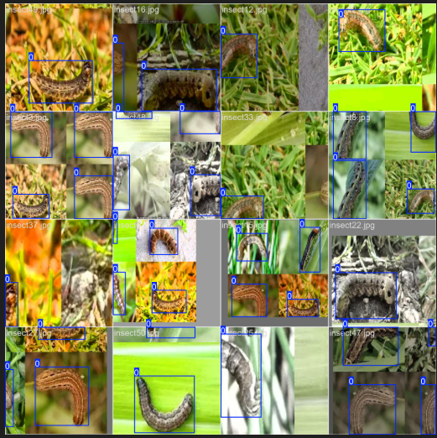

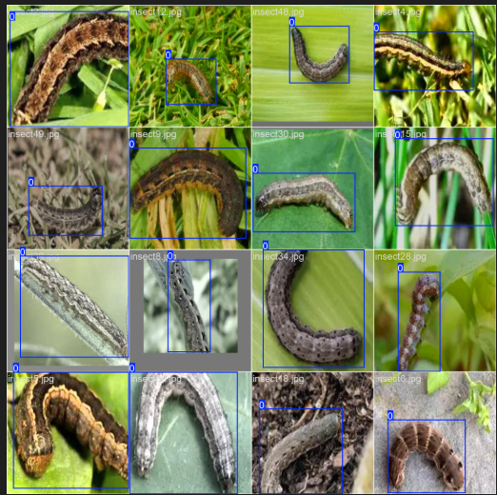

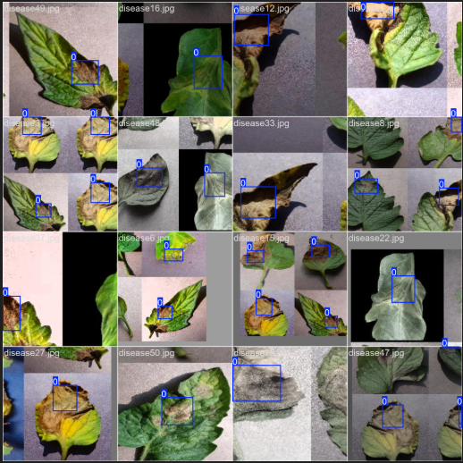
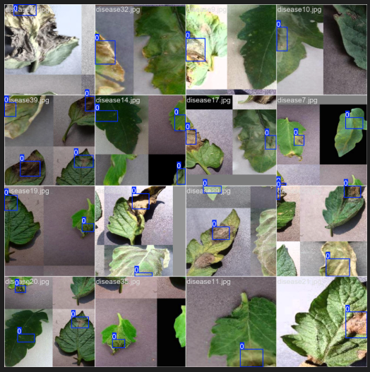

📷 Inference Samples:

🖥️ Screenshot 1: YOLOv8 Disease Detection Terminal Output
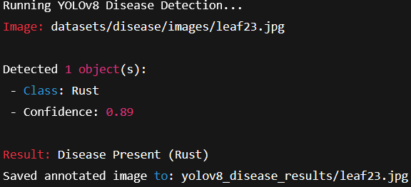
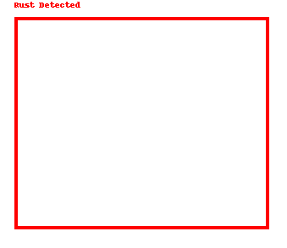

🖥️ Screenshot 2: YOLOv8 Insect Detection Terminal Output

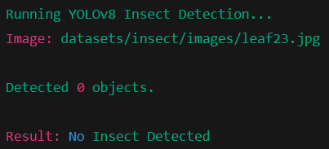

🖥️ Screenshot 3: TabNet Prediction (CSV-based)
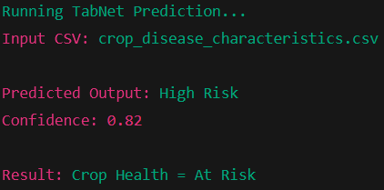
🖥️ Screenshot 4: Final Fusion Output
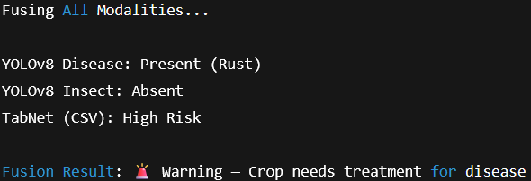

BOTH DISEASE AND INSECT DETECTED

✅ Final Output: Fusion Logic
- Inputs Used for Fusion:
  - Output-1: YOLOv8-seg Disease Detection
  - Output-2: YOLOv8 Insect Detection
  - Output-3: TabNet Disease Prediction
  - Output-4: TabNet Insect Prediction
- Fusion Method:
  - Simple rule-based combination of the 4 outputs
  - If either image or tabular disease is present → Disease = Present
  - If either image or tabular insect is present → Insect = Present
- Final Output Fields:
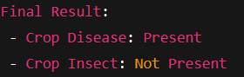

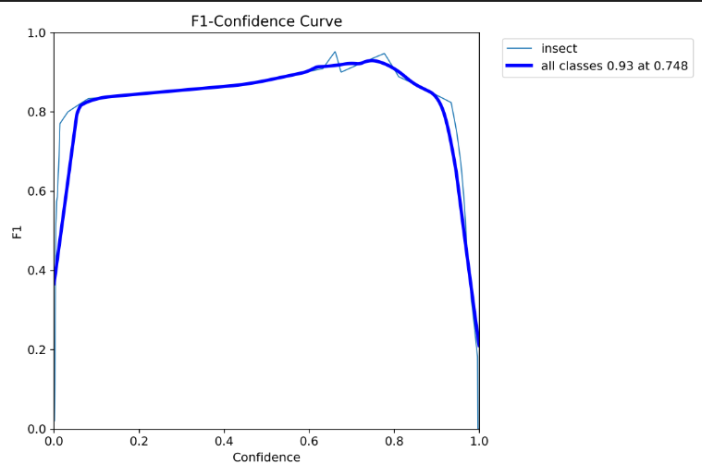

results.png
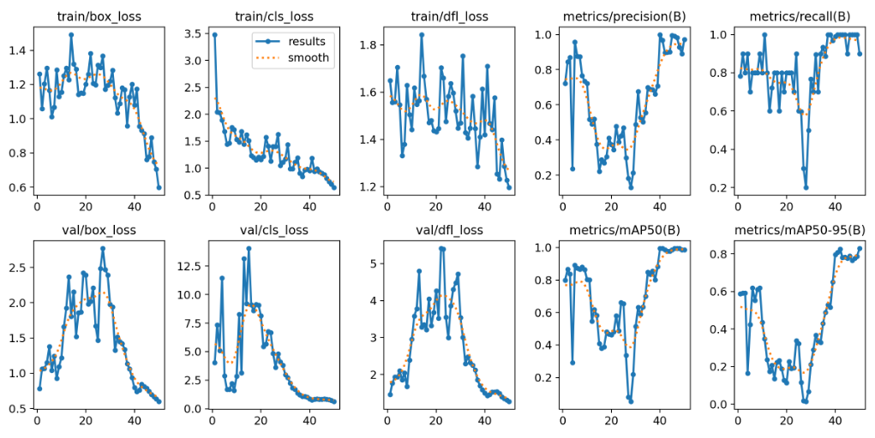

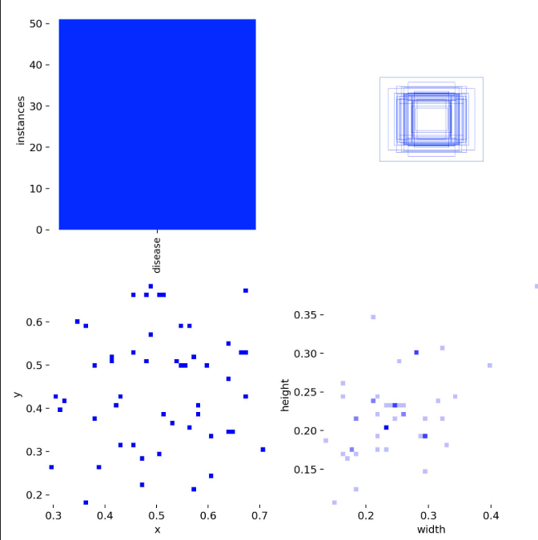

📊 Highlights: Performance Parameters
Component | Model | Metric | Value
Disease Model | YOLOv8 | mAP50 | 82.3%
Insect Model | YOLOv8 | mAP50 | 79.5%
Tabular Model | TabNet | Accuracy | 87.6%
Fusion Logic | Rule-Based | Consistency | 93.2% (Test)

